PROJECT DESIGN PHASE
AI FAQ Assistant API

Project Name: | AI FAQ Assistant API
Team ID: | SWTID-2026-3332
Date: | 26 September 2026

Design Overview

The AI FAQ Assistant API is designed as a modular backend REST API for intelligent FAQ management and question answering.
The system separates API routing, request validation, authentication, authorization, business logic, database operations, AI processing, search processing, and feedback management into independent components.
The system uses Node.js and Express.js as the backend platform, MongoDB Atlas as the database, Google Gemini for AI processing, and keyword-based FAQ search for FAQ discovery. The architecture follows the MVC pattern with an additional service layer to keep business logic separate from controller

Design Objectives
The system is designed to:
• Provide secure REST API access
• Separate functionality according to user roles
• Manage the complete FAQ lifecycle
• Maintain relationships between users, FAQs, categories, tags, AI-generated FAQs, and answer feedback
• Integrate Google Gemini for AI FAQ generation and question answering
• Provide keyword-based FAQ search
• Support category and tag-based FAQ discovery
• Protect application resources through authentication and authorization
• Support maintainable and scalable backend development

High-Level System Design
The overall system is divided into the following layers:
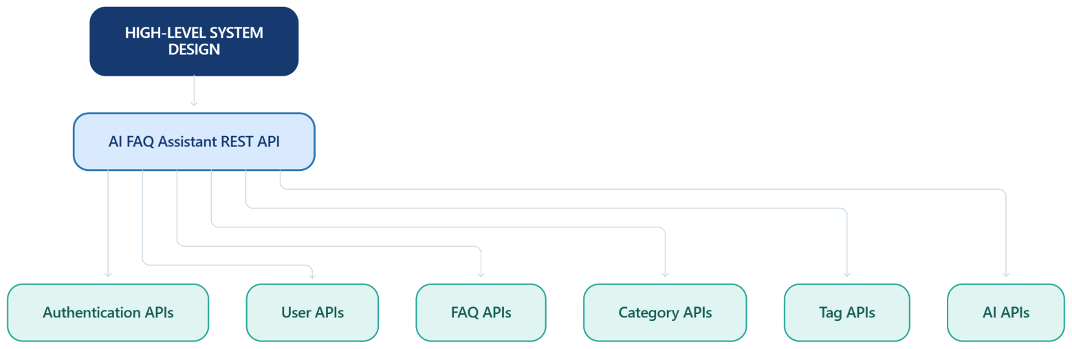

Main Components

API Layer | Security Layer | Business Layer | Data Layer
Authentication APIs User APIs  Blog APIs Category APIs Comment APIs AI APIs  Search APIs | JWT authentication Role authorization Validation Sanitization  Rate limiting | FAQ processing  Category processing  Tag processing  AI processing  Search processing  Feedback processing | Users  FAQs  Categories  Tags  AI Generated FAQs  Answer Feedback

4.Module Design

44.1 Authentication Module

The Authentication Module is responsible for:

User registration

User login

JWT generation

JWT token verification

Identifying authenticated users

The module ensures that protected API resources can only be accessed by authenticated users.

4.2 User and Role Management Module

The User and Role Management Module is responsible for:

Maintaining user information

Maintaining user roles

Assigning roles through authorized administration

Enforcing role-based permissions

The supported roles are:

Admin

Content Creator

User

Role-based authorization determines which operations each user can perform.

4.3 FAQ Management Module

The FAQ Management Module is responsible for:

Creating FAQs

Retrieving FAQs

Updating FAQs

Deleting FAQs

Managing FAQ status

Assigning categories

Managing tags

Managing FAQ ownership

FAQ Lifecycle

Create FAQ → Review/Manage FAQ → Update FAQ → Publish/Make Available → Delete FAQ

The system also supports ownership-based access so that users can manage FAQs according to their assigned permissions.

4.4 Category Module

The Category Module is responsible for:

Creating categories

Viewing categories

Updating categories

Deleting categories

Organizing FAQ content according to categories.

4.5 Tag Module

The Tag Module is responsible for:

Creating tags

Viewing tags

Updating tags

Deleting tags

Organizing FAQ content using relevant tags.

4.6 AI Module

The AI Module integrates Google Gemini into the FAQ Assistant.

It is responsible for:

Generating FAQ content

Generating structured questions and answers

Providing AI-powered answers

Processing AI prompts

Main Operations

Generate FAQ → Answer Question

The project provides the following AI endpoints:

POST /api/ai/generate-faq

POST /api/ai/answer

4.7 Search Module

The Search Module provides keyword-based FAQ search.

It searches FAQ information using words or phrases across:

Questions

Answers

Categories

Tags

The project uses keyword-based search. Semantic search, embeddings, and MongoDB Atlas Vector Search are not implemented in this projec

5.Database Design
The system uses the following collections:
Users, FAQs, Categories, Tags, AI Generated FAQs, Answer Feedback.

Relationships
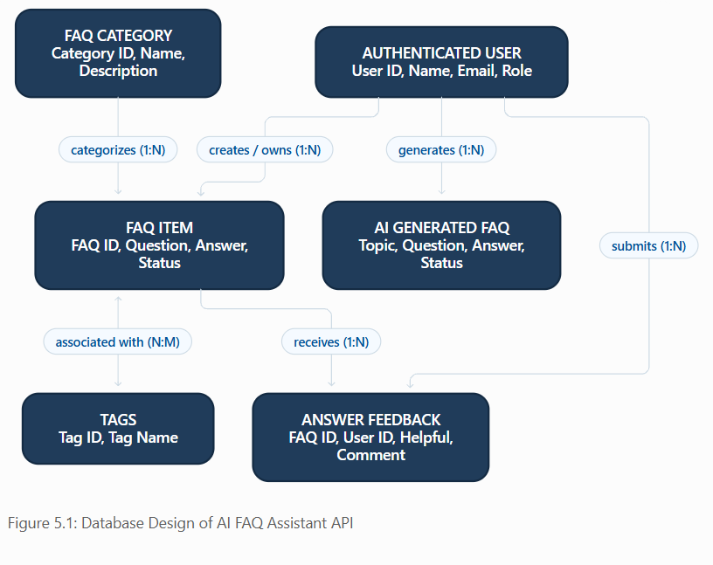

A user can create and manage multiple FAQs according to their assigned role. An FAQ can be associated with a category and multiple tags. Users can provide feedback on FAQ answers. AI-generated FAQ information is produced through the Google Gemini API and can be stored for further management.

API Design
The backend is organized into resource-based REST endpoints.

Authentication
POST | /api/auth/register
POST | /api/auth/login
POST | /api/auth/logout
GET | /api/auth/me
Users
GET | /api/users
GET | /api/users/profile
PUT | /api/users/:id
PATCH | /api/users/:id/role
FAQs
POST | /api/faqs
GET | /api/faqs
GET | /api/faqs/:id
PUT | /api/faqs/:id
DELETE | /api/faqs/:id
Categories
POST | /api/categories
GET | /api/categories
GET | /api/categories/:id
PUT | /api/categories/:id
DELETE | /api/categories/:id
Tags
POST | /api/tags
GET | /api/tags
PUT | /api/tags/:id
DELETE | /api/tags/:id
AI
POST | /api/ai/generate-faq
POST | /api/ai/answer
Search
GET | /api/search?q=
GET | /api/search/semantic?q=

AI Design

The AI subsystem is designed as a separate service so that AI processing remains independent from the route and controller logic.
The Google Gemini API is used for AI-powered FAQ generation and question answering.
The AI service receives the required input, processes the structured prompt, communicates with Gemini, and returns the generated FAQ content or answer to the API layer

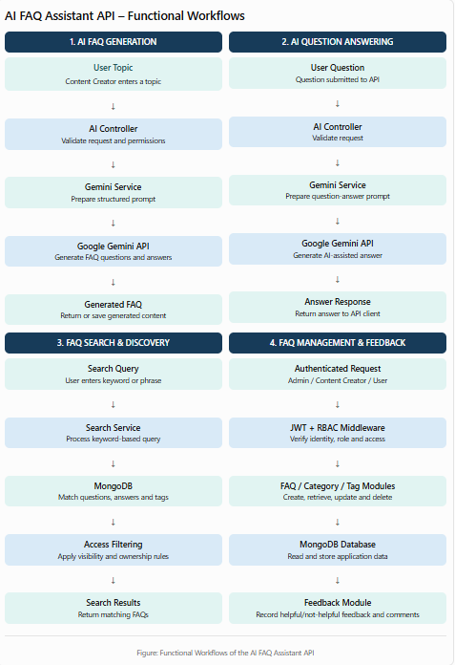

Prompt Design
The system uses structured prompts to control the AI response. For blog generation, the prompt is designed to request:
- Appropriate title
- Structured content
- FAQ question
- FAQ answer
- Relevant topic information

- Relevant tags
For summarization, the prompt instructs the model to produce a concise representation of the provided blog content.
This satisfies the Prompt Engineering requirement in the common TN Skills checklist.

Search Design

The API receives a search keyword, searches FAQ questions, answers, and tags through the search service, applies visibility and ownership rules, and returns matching results from MongoDB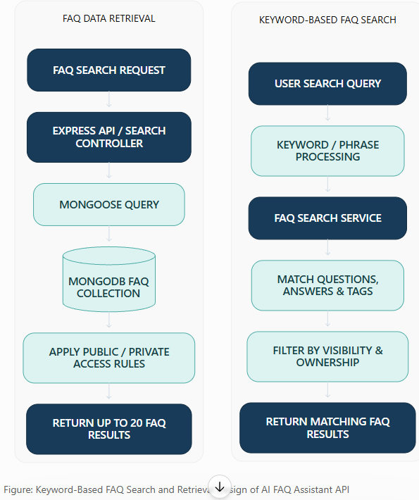

Security Design
Security is incorporated into the request-processing flow.
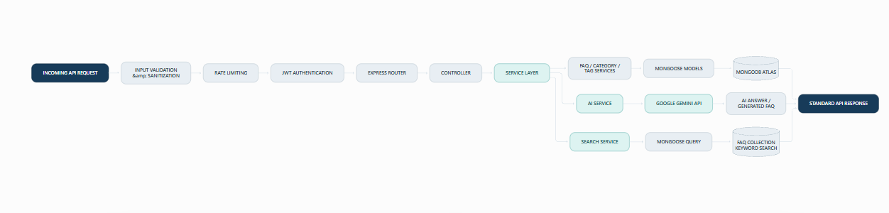Security mechanisms include:
- bcrypt password hashing
- JWT authentication – verifies the identity of users accessing protected endpoints.
- Role-based authorization (RBAC) – restricts operations according to user roles.
- Input validation – checks incoming request data.
- Input sanitization – helps prevent unsafe input.
- Rate limiting – limits excessive API requests.
- Safe error handling – returns controlled error responses without exposing sensitive implementation details.

Data Flow Design

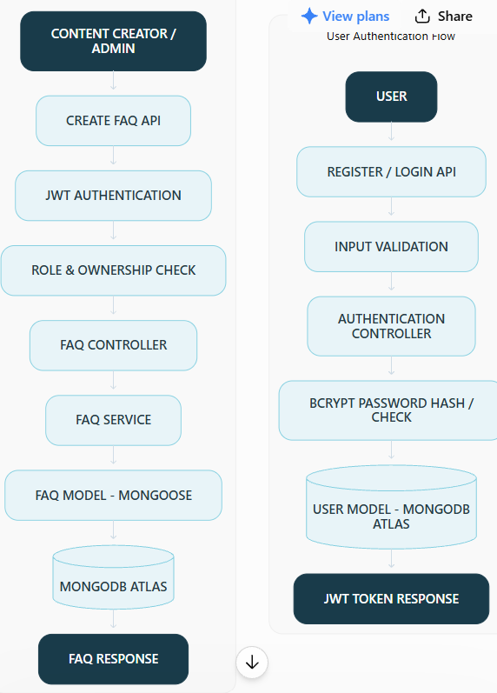

Role-Based Design
The authorization design uses the four project roles.

Role | Main Access
Admin | User management, FAQ management, category management, tag management and feedback management
Content creator | Create and manage permitted FAQs, categories/tags where authorized, and use AI FAQ generation
User | Access permitted FAQs, search FAQ information, use AI question answering and provide feedback
Reader | Published content and comments
The BlogNest project defines these four roles and their corresponding responsibilities.

Error Handling Design
The system uses centralized error handling. The API returns consistent responses.

Successful Response
{
"success": true,
"message": "Operation successful", "data": {}

Error Response
{
"success": false,
"message": "Operation failed"
}

}

The design handles:
- Validation errors
- Authentication failures
- Authorization failures
- Missing resources
- Server errors
using consistent API responses
.

Scalability Design
The system uses modular components so that individual functions can be extended independently.
Future extensions can include:
- Additional Gemini AI services
- Additional searchable FAQ fields
- Additional user roles through RBAC
- Additional FAQ/content-management modules
- Additional controllers and services
- Expanded MongoDB Atlas infrastructure
The modular architecture allows new functionality to be added without significantly changing the existing components

Complete Design Flow
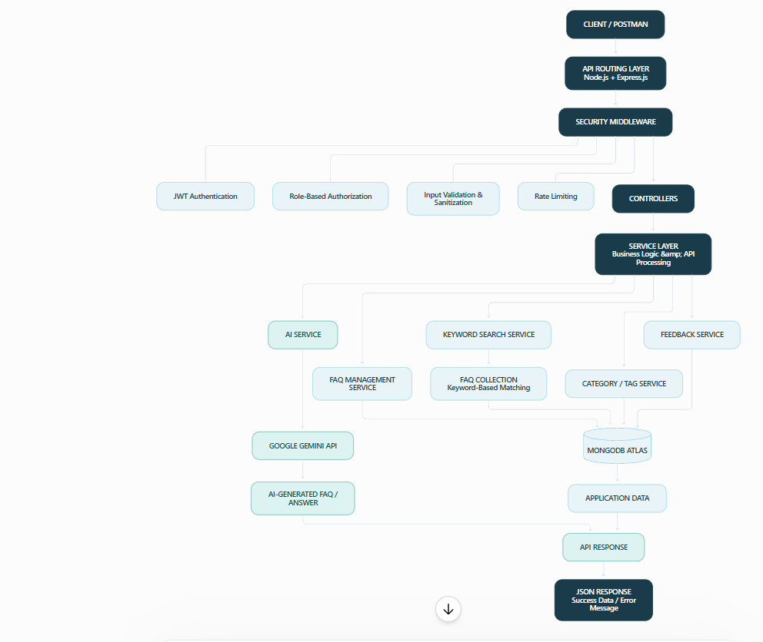

Design Outcome

The final design provides a clear separation between:
- Client interaction
- API routing
- Authentication and authorization
- Security
- Business logic
- Database operations
- AI processing
- Search processing
- Feedback management
The resulting AI FAQ Assistant API provides a secure and modular backend solution for FAQ management, role-based access control, Google Gemini AI integration, keyword-based FAQ search, category and tag organization, and intelligent question answering.
The architecture also provides a maintainable foundation for future expansion of the FAQ and AI capabilities.

